**OFFICE OF THE PRINCIPAL**

**BHURAGAON COLLEGE**

**P.O:-Bhuragaon, Dist.-Morigaon (Assam), Pin-782121**

**Mail.ID-** [**kandarpasaikia50919@gmail.com**](mailto:kandarpasaikia50919@gmail.com)**, Estd.-1988 Contract no 8638125339**

|  |
| --- |
| Ref. No…………………………….. Date… |

**Action Taken Report** **Date:** 14 August 2025

**Subject:** Observation of e-Pledge Against Drugs

As per Government Letter No. E-511405/2024/171 dated 07-08-2025, Bhuragaon College observed an **e-Pledge Against Drugs** on **13 August 2025**.

The program was organized in the presence of students, teaching staff, and other members of the college fraternity. During the event, the importance of creating a drug-free society was highlighted, and all participants took the e-pledge through the designated online platform.

**Key Points of Action Taken:**

1. **Awareness Session:** Teachers briefed students about the harmful effects of drugs and the importance of staying away from such substances.
2. **Pledge Activity:** Students and teachers actively participated in taking the e-pledge against drugs.
3. **Documentation:** Participation details were recorded for official reporting.
4. **Follow-up Initiative:** Posters and digital banners with anti-drug messages were displayed within the campus.

The event concluded with a collective commitment by all present to spread awareness in the community and work towards a drug-free society.

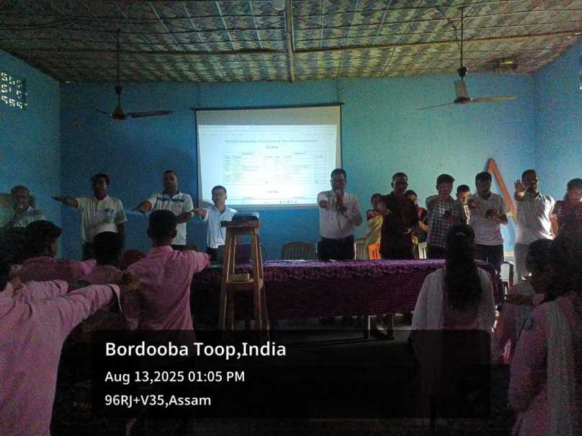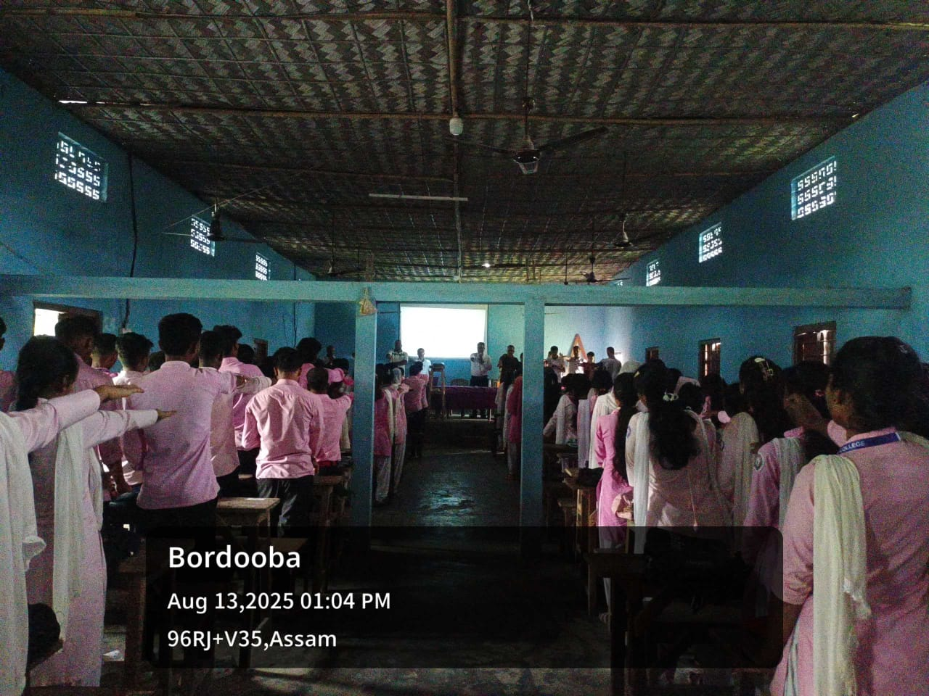

**Principal**  
 Bhuragaon College