**OFFICE OF THE PRINCIPAL**

**BHURAGAON COLLEGE**

**P.O:-Bhuragaon, Dist.-Morigaon (Assam), Pin-782121**

**Mail.ID-**collegebhuragaon@gmail.com**, Estd.-1988 Contract no 8638125339**

|  |
| --- |
| Ref. No…………………………….. Date 28-09-25 |

**Notice**

All the students of **1st, 3rd and 5th Semester (2025)** of Bhuragaon College are hereby informed that the **Internal Examination** will commence from **9th October, 2025**. The detailed examination schedule will be published shortly.

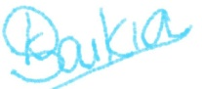

**Principal ic**  
 Bhuragaon College