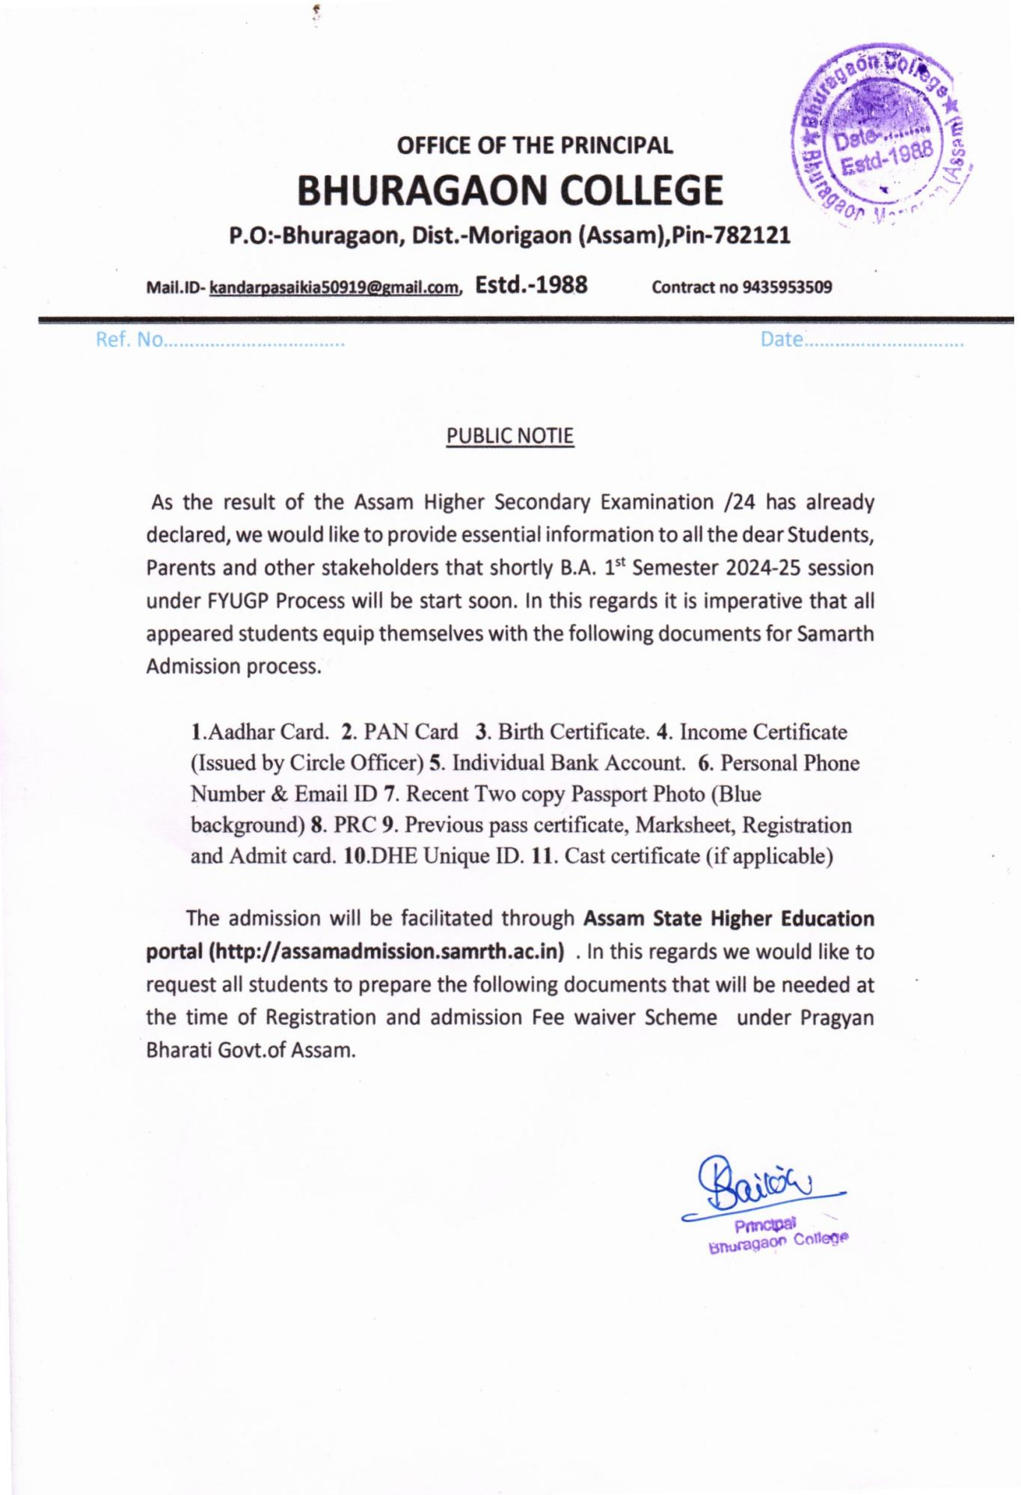

I/518442/2024

### AHE-11/252/2023-HIGHER EDU.-Higher Education

**GOVERNMENT OF ASSAM HIGHER EDUCATION DEPARTMENT**

**DISPUR, GUWAHATI-6**

**.........**

**Ecf No. 294817/ 132 Dated: Dispur, the 3rd April, 2024.**

From : Shri Narayan Konwar, IAS

Secretary to the Govt. of Assam Higher Education Department.

To : 1. The Registrar

All State Universities of Assam

2. The Principal

All Govt/Provincialized/PDUAM/Govt. Model College of Assam

Sub : Regarding acceptance of income certificate issued by Circle Officer for the purpose of admission. Sir/Madam,

In inviting a reference to the subject cited above, this is to inform you that Govt. of Assam in Higher Education Department has decided that only certificate issued by the Circle Officer (competent revenue official) will be accepted for the purpose of granting Fee Waiver in admission from the upcoming academic session 2024 across all eligible Higher Education Institutions who are eligible for Fee Waiver, as per the relevant O.M.

Hence, the concerned Institutions need to communicate with all students about the same and only accept the Income Certificate issued by Circle Officer. Necessary compliance is sought on the matter.

This is for favour of your kind information and necessary action.

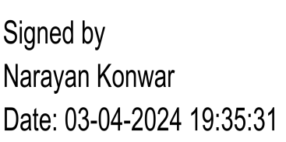Yours faithfully,

Secretary to the Govt. of Assam Higher Education Department

**Memo Ecf No.294817/132 -A Dated: Dispur, the 3rd April, 2024. Copy to :**

1. The Director of Higher Education, Assam for kind information and necessary action.
2. The Nodal Officer, Samarth e-Gov, Assam to make necessary provisions in the Admission portal.

**By order etc.**

(e-Signed)

Secretary to the Govt. of Assam Higher Education Department

### AHE-11/175/2022-HIGHER EDU.-Higher Education

I/518440/2024



**GOVERNMENT OF ASSAM HIGHER EDUCATION DEPARTMENT**

**DISPUR, GUWAHATI-6**

**.........**

**Ecf No.255270 Dated: Dispur, the 3rd April, 2024 N O T I F I C A T I O N**

Pursuant to the decisions of NEP implementation committee meeting held on 16th March, 2024, the Department is pleased to notify the following points for necessary action by the concerned Higher Educational Institution.

1. **Lateral entry:**
   1. The modalities and prerequisites/prior learning for Horizontal Mobility (multiple entry- multiple exit) and Lateral entry for students from Polytechnics in the 3rd Semester will be decided by the Universities/ Autonomous Colleges before the commencement of admission in the year 2024.
   2. The students must have qualified level 4.5 as per NCrF for lateral entry from Polytechnics. All other multiple entry-multiple exit for HEIs other than from Polytechnics will be as per the relevant UGC and AICTE guidelines and the Govt. of Assam’s O.M./Notification issued earlier in this regard.
   3. Supernumerary seats in the range of 5-20 percent may be increased by Institution, subject to the feasibility based on Infrastructural and Faculty availability. However, the range will be 5- 10 percent in case of Technical Institutions, as per AICTE guidelines.
   4. The seats available for every Institution need to be declared against every department in the Samarth portal which will be visible to students for deciding whether or not to go for it.
   5. 4th Year Curriculum for the current CBCS students, as per UGC notice no. F. No. 60-1 (QIP/ Misc.)/2024 dated 1st March 2024
   6. Provisions for 4th year UG programme- Hons with Research or 4th year with Hons may be made by all HEIs offering migration of present CBCS students, as per UGC Credit and Curriculum framework, 2022.
   7. Relevant curriculum and modalities for facilitation of this migration to be worked out by the concerned University/ Autonomous college with an organic progression from 6th semester syllabus under CBCS to the 4th year (like NEP) exploring the scope of Level 6, as per NEP- 2020 into one year PG course (Level 6.5), maintaining the learning levels, as per NCrF. Curriculum would be the same both for the Universities/Autonomous Colleges/Affiliated Colleges.
2. The 4th year UG programme- Hons with Research or 4th year with Hons for the current CBCS students to be mandatory for the Universities to offer and optional for Colleges. Any single department in a College may also start the 4th year UG, as per feasibility.
   1. Students graduating under CBCS plus one UG programme and Four Year Undergraduate Programme (FYUGP) to be treated at par with each other and be accordingly notified to ensure that parity is given in degree recognition, academic progression and employability.
   2. The scheme of 7 years to complete FYUGP degree under NEP-Multiple Entry-Multiple Exit shall not apply to the students under CBCS plus one UG programme but they will follow the erstwhile University timeline for the CBCS degree courses with one additional year, depending on requirement.

### AHE-11/175/2022-HIGHER EDU.-Higher Education

I/518440/2024

* 1. Preparation of curriculum for both 4th year UG programme- Hons with Research or 4th year with Hons and according statutory approval to the programme to be done on or before 15th May, 2024.
  2. The curriculum for one year PG to be specially curated/prepared to cater to progression of students under CBCS plus one UG programme and be accorded statutory approval by 15th Dec, 2024.

1. B. Ed admission modalities to be worked out and provisioned through Samarth.

*This comes into force with immediate effect.*

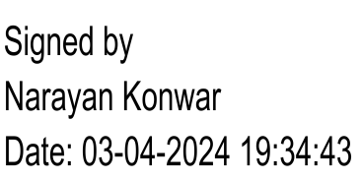(Shri Narayan Konwar, IAS) Secretary to the Govt. of Assam Higher Education Department.

**Memo Ecf No.255270-A Dated Dispur, the 3rd April, 2024 Copy to:**

1. The Director of Higher Education/Director of Technical Education, Assam for kind information.
2. The Registrar, All State Universities of Assamfor kind information and necessary action
3. The Principal, All Autonomous Collegesfor kind information and necessary action
4. The Principal, All Govt/Provincialized/PDUAM/Govt. Model Colleges of Assam

**By order etc.,** Secretary to the Govt. of Assam, Higher Education Department

**User Guide**

**Assam State Higher Education Admission Portal**

**2023-24**

A comprehensive user guide for students for Assam State Higher Education Department admission process.

**Table of Contents**

**Introduction**

**Website Walkthrough Home**

**Notice Institutions**

**Programme Information FAQs**

**Contact Us**

**The Admission Process Registration**

**Applicant Dashboard Login**

**Profile Details Other Details Uploads Preview**

**Programme Selection Academic Details**

# Introduction

**Website Walkthrough**

The admission portal for Assam Higher Education Department. Menu items in the admission portal are as follows:

* **Home**
* **Notice**
* **Institutions**
* **Programme Information**
* **FAQ**
* **Contact Us**
* **New Registration**
* **Login**

## Home

The home button takes the user back to the home page. It is the landing page of the portal. The home button is useful for applicants who want to quickly return to the home page while navigating to other pages in the portal.

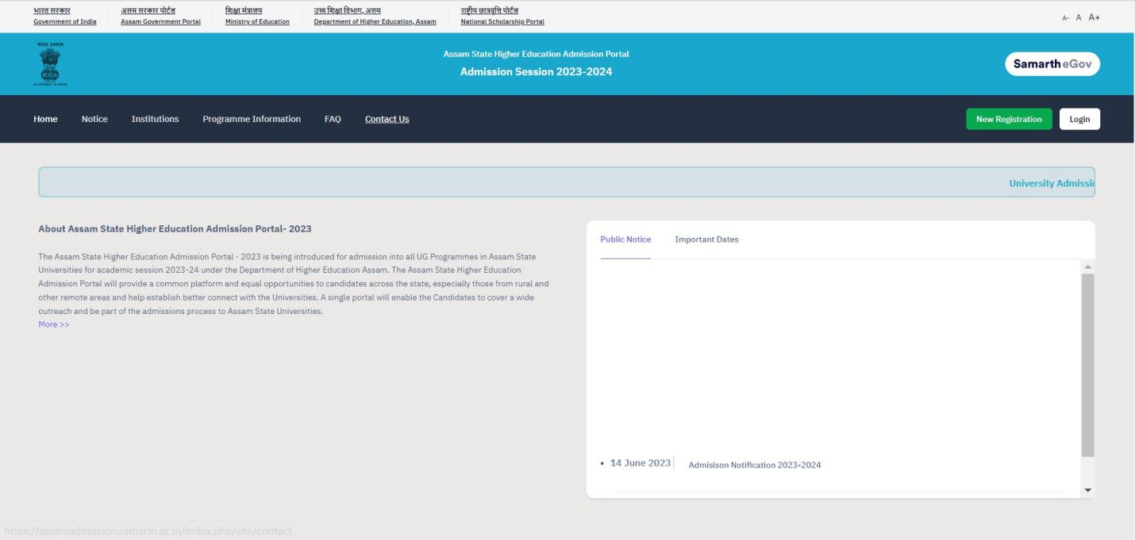

## Notice

Notices are announcements that are made about upcoming events or changes in laws or regulations. They are important for applicants to be aware of. It typically includes notices, ordinances, permits, and other important announcements.

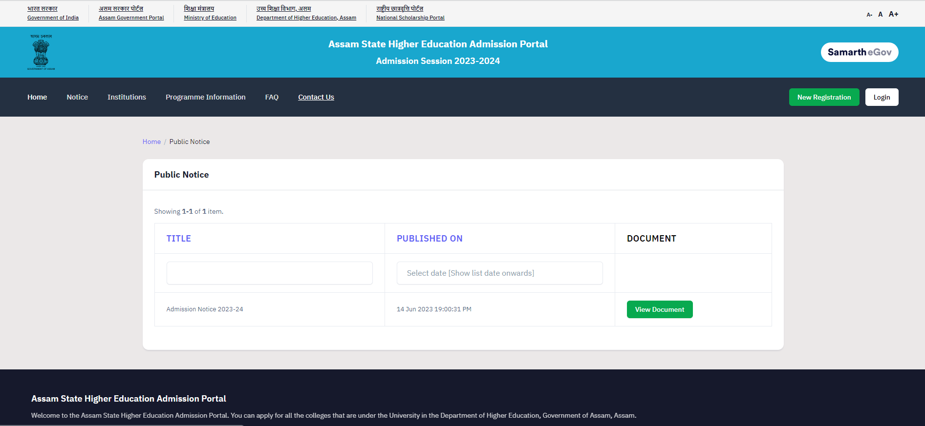

## Institutions

The ‘Institutions’ section provides detailed information about the participating Institutions. Applicants can access the page to view and read the Information Bulletin of the Colleges.

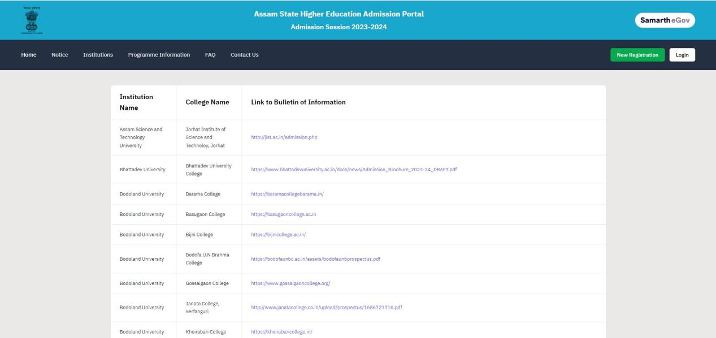

## Programme Information

The programme information section displays a comprehensive list of admission registration programs. Within this section, applicants can explore Universities and colleges that offer their desired programs, specifically within the designated colleges of those Universities.

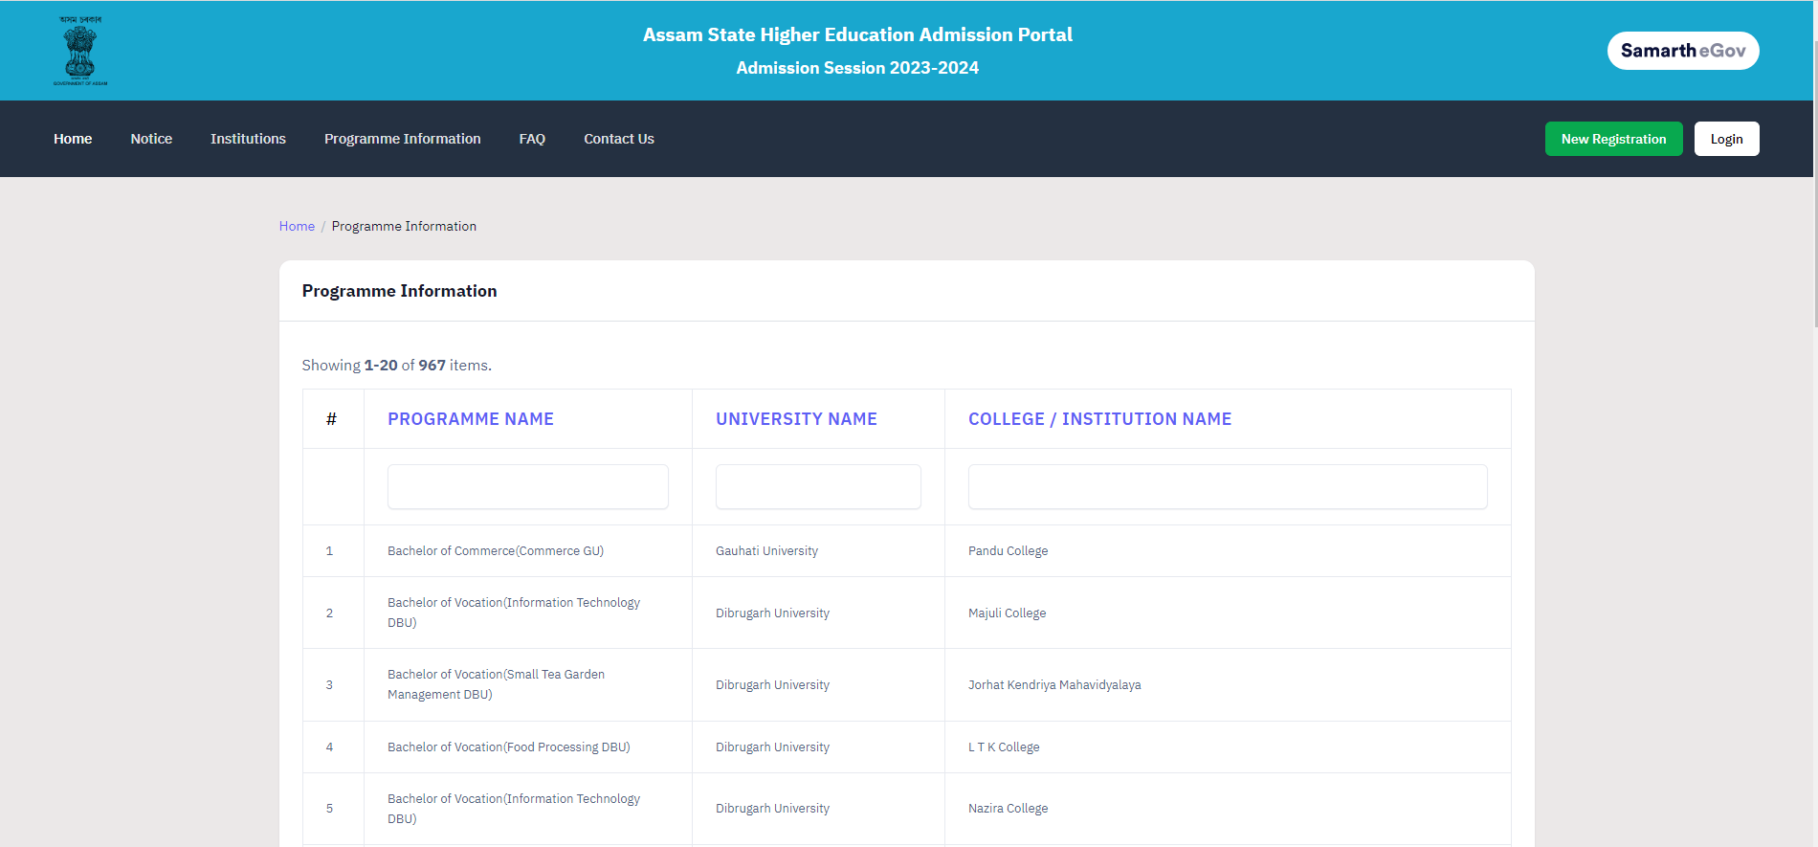

## FAQ

The FAQ (Frequently Asked Questions) section is a helpful resource that provides answers to commonly asked questions regarding a particular topic or subject. It is designed to address the most common queries or concerns that applicants may have, offering clear and concise explanations. The FAQ section aims to provide applicants with quick access to relevant information, saving them time and effort in searching for answers.

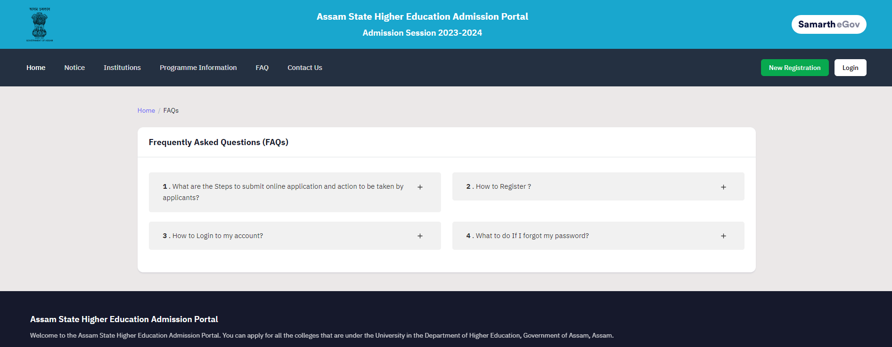

## Contact Us

The Contact Us section provides University/College contact details, which applicants can visit if they have any queries relevant to those Universities/Colleges.

# The Admission Process

The admission process is divided into 4 steps. The applicant is required to register in the portal and complete all the steps as follows:

1. Complete their profile,
2. Confirm and lock profile and
3. Apply to college

To start the admission process, the applicant needs to register and log in to the portal. Registration for admission is a one-time process and every applicant needs to register. The registration process is mentioned below:

## Registration

Applicants who are new to the portal need to register to process their application for admission. Registration is a must to ensure the portal that applicants want to apply for University programmes.

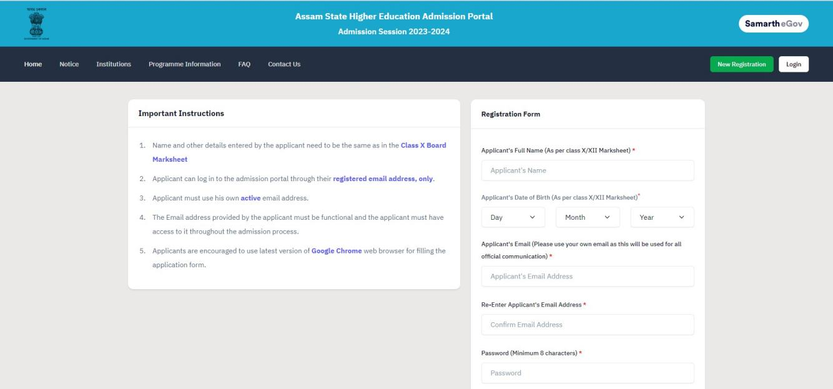

To register on the admission portal:

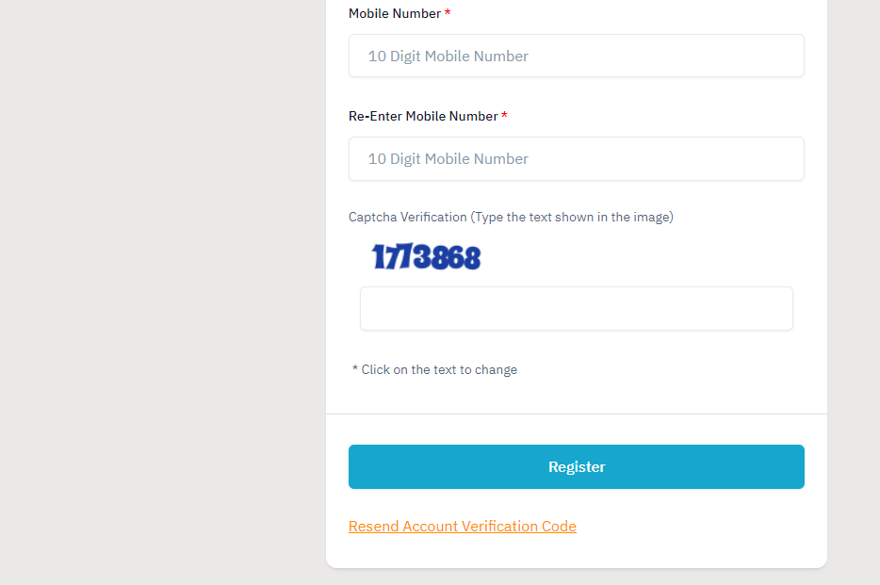

**Click** on the **New Registration tab.**

There are two sections on the ‘new registration’ page.

**Read the Important Instruction section** before registering on the portal

**The student registration form requires correct details.**

**Add the Full Name of the Applicant** in **the** Applicant’s Full Name **Add Date of Birth in the format of Day, Month, and Year Mobile Number of Applicant** in Enter Mobile Number

**Set your account password** in Enter Password

**Enter Captcha for verification Click on Register**

**An OTP will be sent to the registered mobile number. Enter the OTP. After this the account has been successfully registered.**

# Applicant Dashboard

The applicant dashboard gives the applicant a personalized space to check their application status, edit/update their profile and apply to multiple programmes added by the University. This makes it easier to manage multiple applications in one place.

To access the dashboard, the applicant needs to complete the registration process and login to the portal.

## Login

The ’Login’ section is the starting point for applicants to apply for the programme.

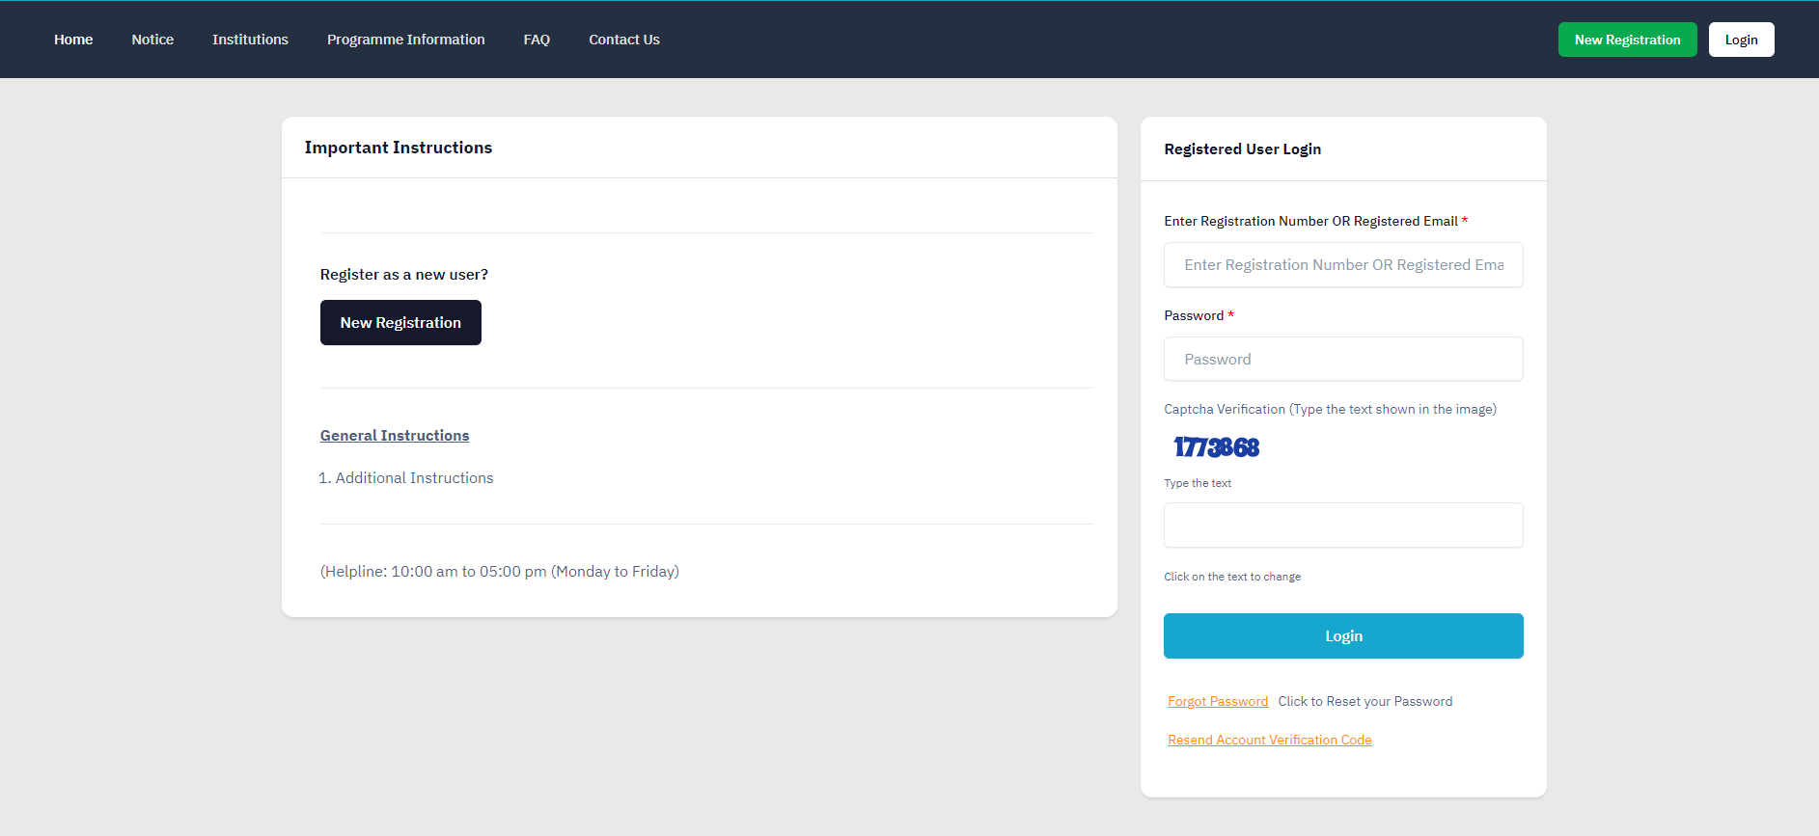

To login into the portal, the applicant needs to click on the login button followed by:

**Enter your registered mobile number. Enter** the **password**

**Enter** the **captcha for verification in the type text box.**

**Click** on **login to enter the portal**

**(Note: if you forget your password click on the ‘forget password’ link which will redirect the applicant to the Request Password Page, for which the applicant needs to add the registered Email id. Enter the Captcha for verification and click send. A new password will be sent to the applicant's registered email id).**

After successful login, the applicant can start their application process for admission. **Profile Details**

Applicants are required to fill in their profile details in the profile section. To complete the profile, click on the **Complete Profile** button in the dashboard.

The profile section is divided into five sections:

* **Personal Details**
* **Family Details**
* **University Registration details (if any)**
* **Other Category/Quota**
* **Address**

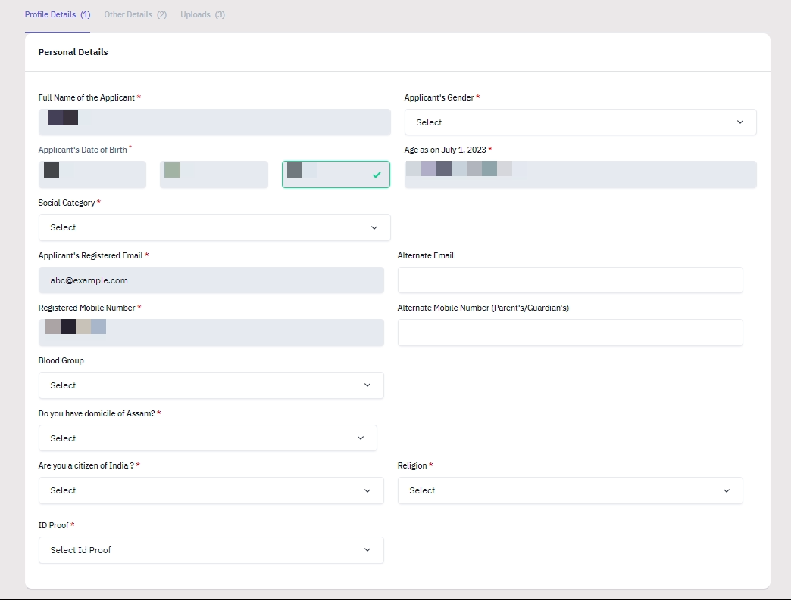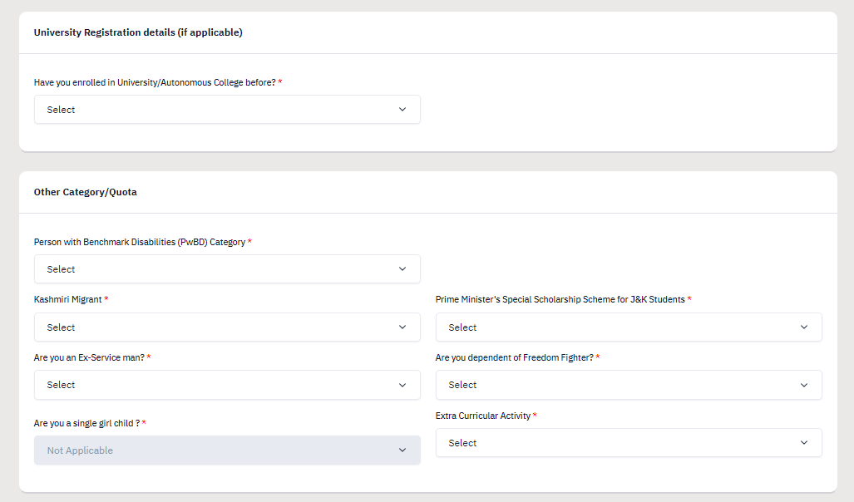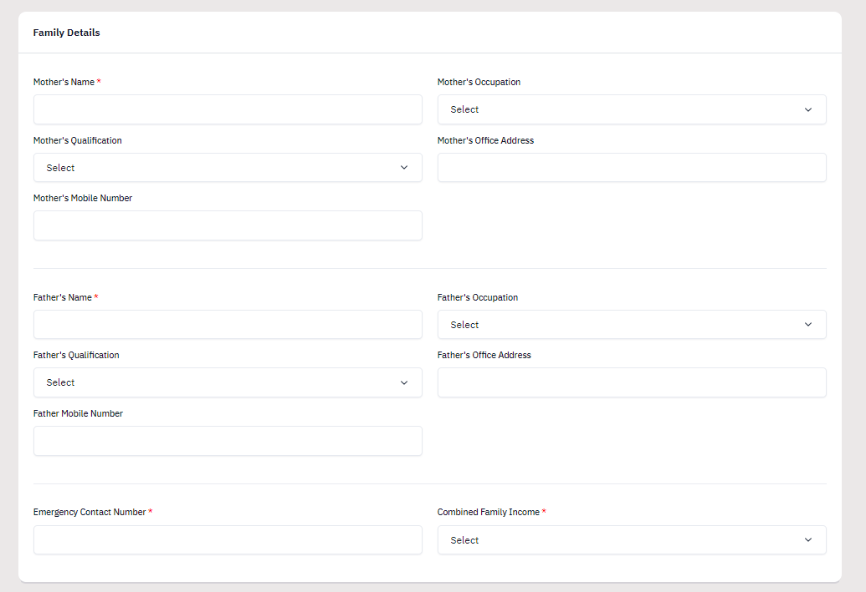

After filling all the given details, click on **Save and Next** button to proceed to the next section.

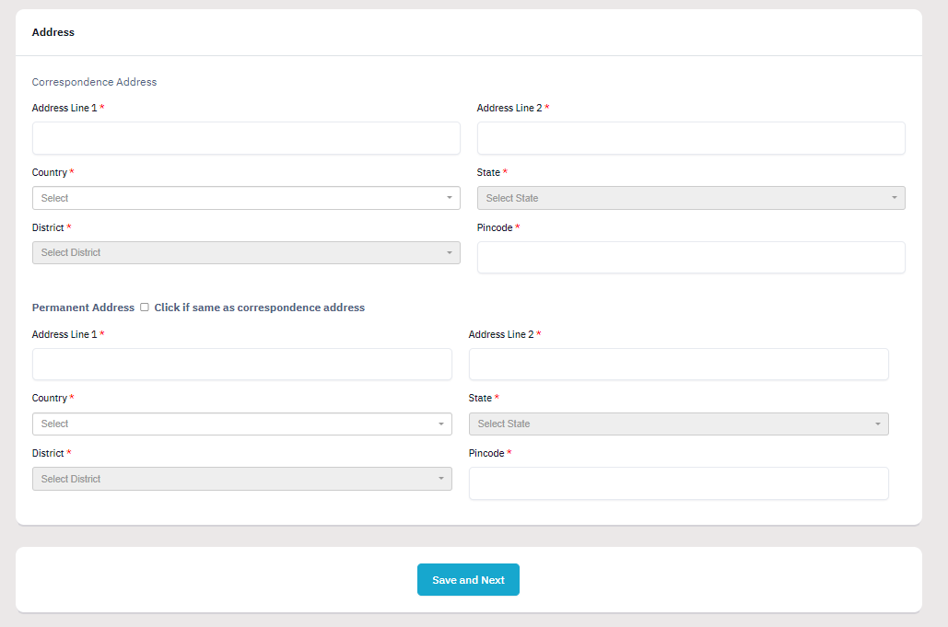

The applicant is required to verify all details for which the portal provides a preview page before the applicant starts filling the ’Other Details’ section. If the applicant finds any wrong input or any issues in the form, they can easily edit or update their profile section before proceeding to the next section.

To edit/update any details:

Click on the **Update Details button** to update.

The applicant’s profile will be saved. Before proceeding to the next section, please preview the filled-in details by checking all the form details and click on **Proceed to Next** button to proceed to the next section.

## Other Details

Applicants are required to fill in this section. Click on the **Other Details** button after saving profile details at the top section bar or click on **Proceed to Next** button from the preview section.

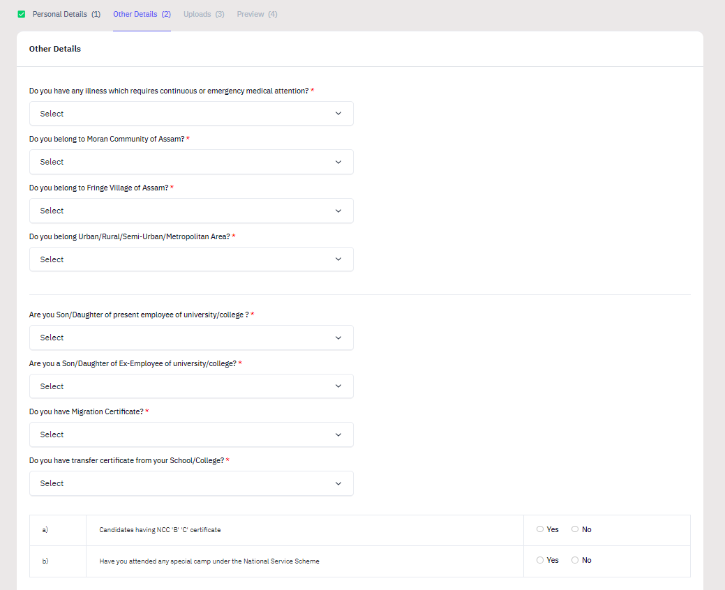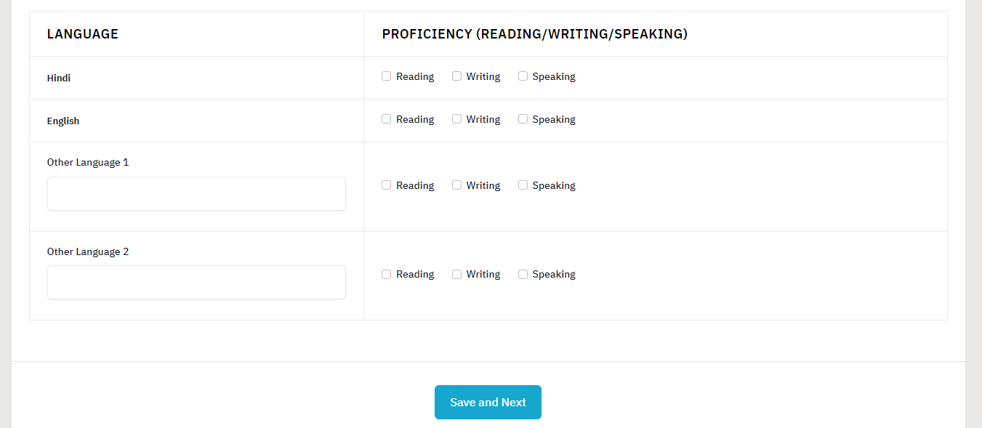

## Uploads

The ’Uploads’ section asks for relevant documents which have been mentioned by the applicant in their profile and other details.

To upload documents:

**Click** on the **uploads section** or **click** on **Proceed to Next** button on the other details page at the bottom.

**(Note: Please read the instruction carefully before uploading your documents)**

**Instruction for Uploading Image/Photo of Document, Certificate, Marksheet, and Signature**

* **Digital photos and signatures are required in .jpg or .jpeg image format.**
* **File size of the digital photo must be within 10kb to 500.00 KB limit.**
* **Document/Certificate/Marksheet related size of the digital photo must be within 10kb to**

**500.00 KB limit.**

After uploading the required documentation according to the given format, click on the **Preview Your Profile** button to proceed to the next section.

## Preview

The preview section provides a final reviewing process for the applicant's application form. Here the applicant can check their full application form and verify it before submitting for their admission application.

Applicants can also edit their form by clicking on the **Edit** button if they find any wrong input or issues.

**(Note: After verifying all the details, the applicant needs to check the declaration box proclaiming that all the information given is correct.)**

After checking the box, click the **Confirm and Lock** button to confirm and proceed to the programme selection section.

**(Note: After submitting the profile, the applicant will not be allowed to edit the details further.)**

## Programme Selection

As soon as the profile details are completed and confirmed by the applicant, the will be able to select the programmes added by the University.

(Note: The Applicants can also view the applications which are not submitted yet from the Dashboard)

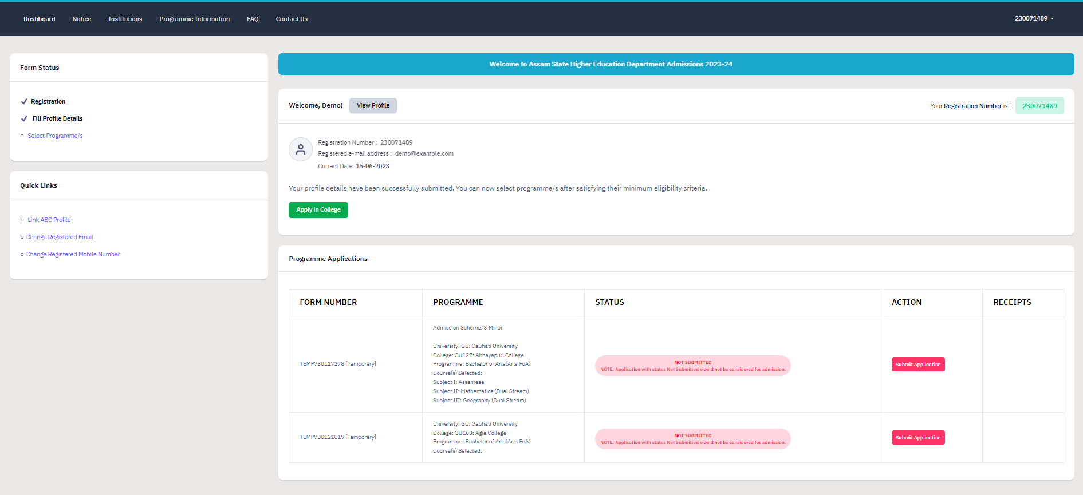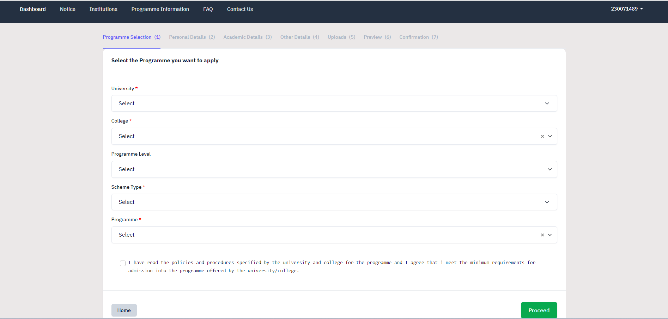

**(Note: Before applying for any programmes, applicants can check the University and college through the Programme Information page).**

To select the programme, click on **Apply in College** on the dashboard.

**Select** the **University** from the list.

**Select** the **Colleges** from the list affiliated with the selected University.

**Select** the **Programme** level from the list.

**Select** the **Scheme Type** from the list.

**Select** the **Programme** from the list.

**Check** the declaration box at the bottom of the page regarding the Information Bulletin. Click **Proceed**

After selecting the desired programme, the applicant is required to select courses according to the group mapped by the University/College to programmes.

**(Note: For detailed information on Subject Selection Criteria, the applicant should refer the university/college admission rules)**

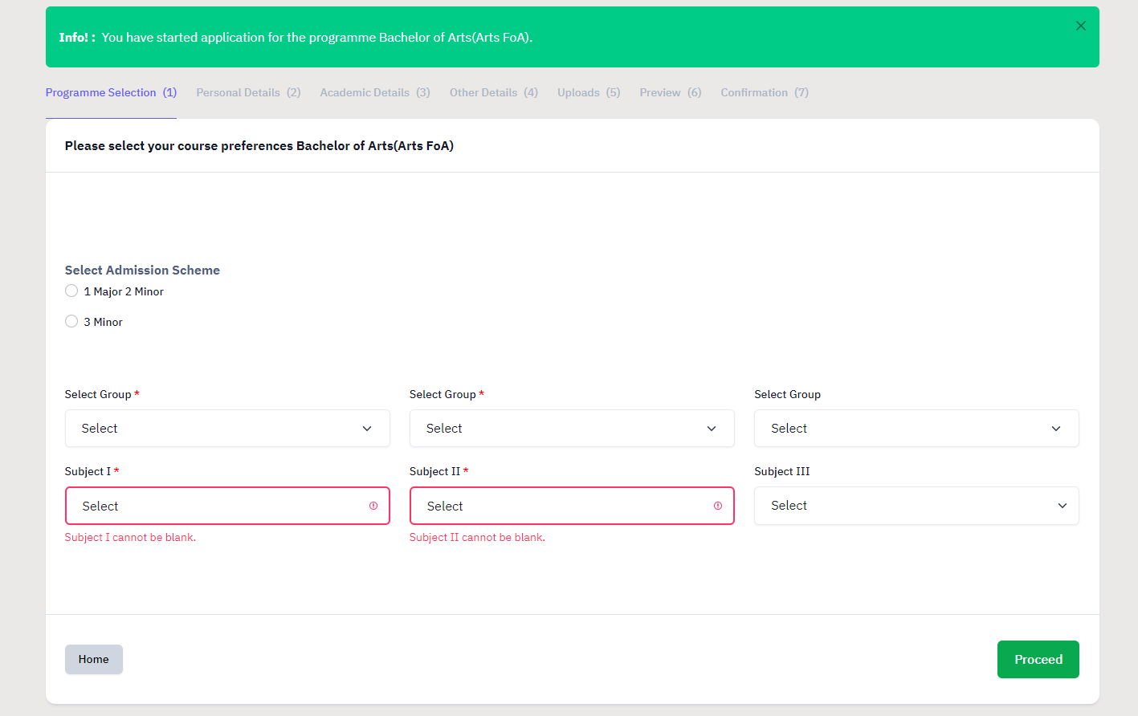

**Select** Admission Scheme

**Select Group** from the dropdown

**Select Subject I** from dropdown

Repeat above process for **selection of Subject II and Subject III**

Click **Proceed**

After selecting the groups and subjects for their selected programme, the applicant needs to provide their academic details.

## Academic Details

The academic details sections need to be filled by the applicant according to their academic details which require qualification details of Secondary and Senior Secondary from the applicant.

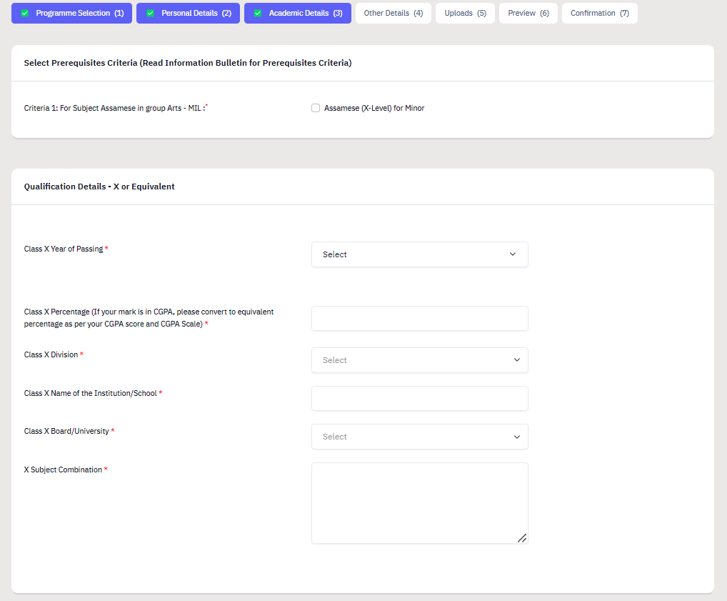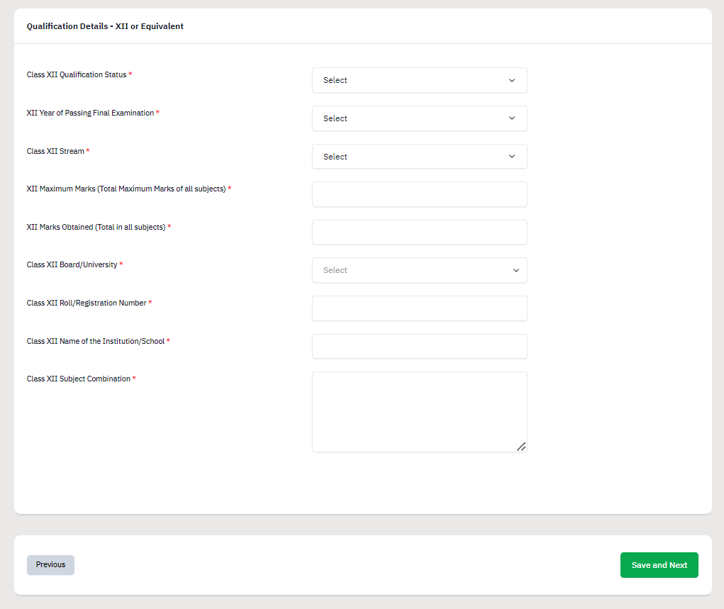

## Other Details

The applicant needs to verify the “Other Details” section which is pre-filled according to the details entered at the time of Profile Completion.

Click “Next” to proceed to the “Confirmation” Page.

## Confirmation & Submit Application

On this Page, the applicant needs to verify the details as entered by them by clicking all the checkboxes. After verification, the “Submit Application” Button is activated and the applicants can submit their application for the selected programme.

